A guide to reconnecting your alarm system to the internet
You will first need to know how your system is connected. Have a look at your control panel (the big plastic or metal box, usually hidden away somewhere like an airing cupboard or in the loft). Your control panel will be connected with one of the following methods:

- TP Link WiFi Extender (WA855RE V2-V5 and WA855RE V1):

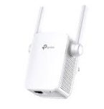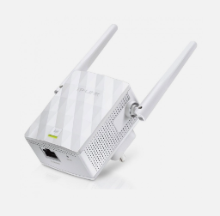

- TP Link Powerline Adapter (PA4022P):
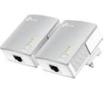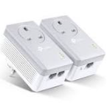
- MERCUSYS WiFi Extender:

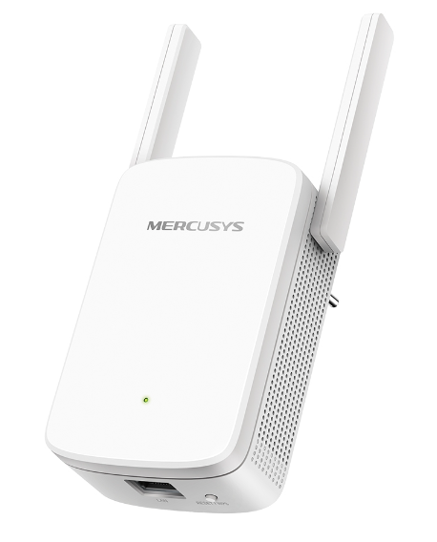

- MERCUSYS Powerline adapter:

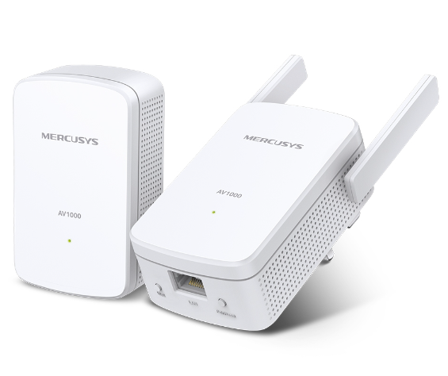

Follow the appropriate guide when you know how your alarm is connected by clicking on the appropriate image in this document (you may have to CTRL + Click). Alternatively, head to wmbradley.co.uk/downloads and find the appropriate guide there. If none of the above methods appear to have been used, there are a few other options:

- Vonets WiFi bridge - This device will be inside the control panel and will therefore require an engineer visit to reconnect. Please contact our office to arrange.

- Wired connection - This means your alarm has been hard wired from the control panel directly to the router. Check this has not been unplugged. If it is plugged into the router and the alarm still has no connection, please contact our office to arrange an engineer visit.

- Built in WiFi connection - If you have a Risco LightSYS+, a Pyronix Enforcer or a Pyronix Euro-46 (see our initial quotation or completion paperwork to find out your system’s make/model under the heading “Control Equipment”), you will need to follow the instructions on reconnecting to the WiFi network laid out in the appropriate user guide. If you need a copy of the user guide, see our downloads page: wmbradley.co.uk/downloads

If you need any further help, please phone our office on 01625 575608.

